Cheryl L. Behymer
Partner
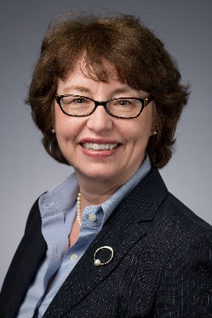
Cheryl Behymer is a Partner in the Columbia office and Co-Chair of the firm’s Pay Equity Practice Group, as well as the Affirmative Action and Federal Contract Compliance Practice Group. She assists clients by providing timely and practical counsel, training and audit defense in affirmative action, workplace harassment, employee leave issues involving the Family and Medical Leave Act (FMLA) and the Americans with Disabilities Act (ADA), and other labor and employment issues.
Cheryl defends employers who are responding to administrative charges, actively involved in litigation, or are participating in compliance reviews conducted by the Office of Federal Contract Compliance Programs. Cheryl prepares affirmative action plans for federal contractors and subcontractors and assists federal contractor and non-federal contractor clients with self-audits, including compensation audits. She also defends employers in multi-plaintiff lawsuits, including class and collective actions.
Cheryl is a frequent presenter on pay equity, compensation, affirmative action, and harassment legal issues. She is also past chair of the South Carolina Diversity Council, a committee of the South Carolina Chamber of Commerce, and a diversity fellow of The Diversity Leadership Institute affiliated with the Riley Institute at Furman University. Cheryl is an Ambassador for the South Carolina Diversity Recruitment Consortium, and she is a former board member of the South Carolina ILG. Cheryl regularly presents on federal contract compliance at the ILG National Conferences, served as Co-Chair for the 2016 National Conference for the Industry Liaison Group, and regularly presents and publishes with national, state and local organizations and publications.

